**Guatemala Case B:**

**The Todos Hermanos Cooperative, Revisited**

**What Actually Happened**

Though the 2012 Business on the Frontlines team thought they had gone to Guatemala to consult on the commercialization of bananas, in reality the challenges facing Cooperativa Todos Hermanos were much different. After visiting the Del Monte plant, comparing retail and bulk banana prices, and analyzing the international market, the team concluded that there was no way a tiny cooperative could profitably compete in banana production. To make matters worse, the cooperative manager, Emilio, had finally opened up his books and admitted that the co-op stood on the verge of bankruptcy. If something didn’t change soon, the co-op would soon need to be dissolved and its assets liquidated.

Understanding the gravity of the situation, the BOTFL team made several strong recommendations. To stabilize earnings, they recommended that the cooperative rent out its coffee mill to other farmers and organizations, at a profit. To provide for the future stability of the co-op, they recommended that Emilio either be replaced or be given a suitable support team to fill in his skill gaps. Finally, to strengthen co-op governance, they recommended that CRS invest in encouraging more participation from member-farmers.

Fortunately, Todos Hermanos took the BOTFL recommendations seriously and began to implement the changes. Karla, a BOTFL IV team member, had developed a relationship with the co-op and kept in contact from time to time to see how they were doing. A year after their visit, she emailed Emilio and was delighted to learn that they had sold 3X the previous year’s coffee volume, that they had been developing corporate relationships for promising future sales growth, and that they working towards organic certification. It seemed like a very happy ending.

**Return to Guatemala**

One year after her last message from Emilio and two years after her initial visit, Karla found herself back in the offices of Catholic Relief Services, Guatemala. She had returned to the country as a translator for the BOTFL VI team, who had been tasked with tracing a niche agricultural value chain for a grain called amaranth. Many of the same CRS staff members still worked in the office and Karla looked forward to the reunion. When she arrived, the CRS staff greeted her with warm smiles and chatted enthusiastically, in Spanish, while the new BOTFL team members made their introductions. But their bright expressions turned to concern, when she eventually brought up Todos Hermanos. Though the staff was hesitant, at first, they finally confessed that the cooperative was once again on the verge of collapse. In less than a month, they explained, they would hold a meeting of the General Assembly to determine whether or not to dissolve the cooperative. Though the causes of failure were unclear, the CRS team seemed to be pointing the blame at Emilio and what they perceived as a lack of transparency. According to them, Emilio had refused to share financial records with CRS and the co-op members but nothing could be done to enforce any oversight because the co-op members were too scared and unwilling to vote against him. Perhaps this was because they knew how unlikely it would be to find a qualified replacement.

Karla’s heart sank when she heard the bad news. She thought of all the farmers her team had met, who would once again be vulnerable to usurious intermediaries and violent narco-traffickers. It was almost too much to bear. Karla spent the next two weeks traveling with the new BOTFL team, but in the back of her mind all she could think about was Todos Hermanos and what could have been done to prevent such a tragedy. As a peace-building practitioner, her mind struggled to process the implications of the co-op’s failure and understand how this should impact future programming decisions.

**What went wrong?**

Todos Hermanos was formed by a strong community leader, the Bishop Rossolino Bianchetti Boffelli, who was lovingly referred to as Monseñor. Monseñor was loved by the people for his humility and his historic support of the indigenous people during periods of Guatemalan genocide. Farmers in Zacapa trusted the Monseñor and followed him. Without his leadership, Todos Hermanos would not have attracted sufficient enrollment.

Unfortuantely, Monseñor was transferred to another part of the country, one year after Karla’s first visit. His departure was a great loss to the community and it weakened the cooperative. Without their trusted leader, the member-farmers lost faith in the cooperative and began to doubt its manager, Emilio. Participation in co-op governance faltered and, with it, oversight diminished.

In Karla’s memory, Emilio was a man with a great heart and a sharp mind. He had the education and business training that qualified him for a more glamorous job, but he chose to stay in Zacapa because he believed in the cause. However, Emilio’s work was stressful. He traveled hours each day through the mountains to meet with the widely dispersed membership, often arriving home past dark. He did not have secretarial or accounting support, or other trained professionals to consult with. To make matters worse, Emilio’s professional demands were affecting his home life and his wife was unsupportive of his chosen vocation. “Could Emilio have eventually cracked under the pressure?”, wondered Karla.

Or could this be a case of intentionally sabotaging the business? When her team first recommended that Todos Hermanos rent out their coffee mill, they were keenly aware that doing so placed the co-op at risk of inadvertently doing business with narco-coffee groups, who used coffee production as a money-laundering scheme. If this had occurred, then Emilio could have been subject to threats or external pressures from narcos. “Did Emilio’s lack of transparency suggest that he had become intertwined, perhaps unwillingly, with drug traffickers?”, Karla speculated. In truth, she would probably never know the answer.

**Alternative Models**

### Agricultural Associations

While traveling and translating, Karla got to observe a number of agricultural organization models. The BOTFL VI team visited several amaranth groups, many of which were organized as farmer’s associations instead of cooperatives. Like a cooperative, an association is centered around a social goal and exists to provide certain benefits to farmers, such as enabling economies of scale, increasing bargaining power, sharing costs of new technology, adding value to agricultural products, gaining access to new markets, and spreading around the risks associated with new enterprises.

The key difference between a cooperative an association comes down to ownership: cooperatives are owned by their members, while associations are non-profit organizations that, by definition, exist without owners. By comparison, a cooperative’s collective ownership structure can strengthen community ties and empower member-farmers to have more input in organizational decision-making. Ho wever, this same ownership structure is sometimes more vulnerable to the classic free-rider problem, than other models, and its democratic decision-making process can also decrease operational efficiency.

The Asociación Qachuu Aloom was an example of a very successful association, whose primary mission was developing the community. Qachuu Aloom functioned as a benevolent intermediary, which connected farmers to markets through bulk purchasing and resale. Profits were reinvested in programming for members, such as agricultural and nutritional trainings. Though the association accepted donations, it had the long-term vision of being self-sustainable. While visiting Qachuu Aloom, Karla couldn’t help but note that their model seemed to offer many of the benefits traditionally associated with cooperatives without the messy governance that resulted from the democratic process.

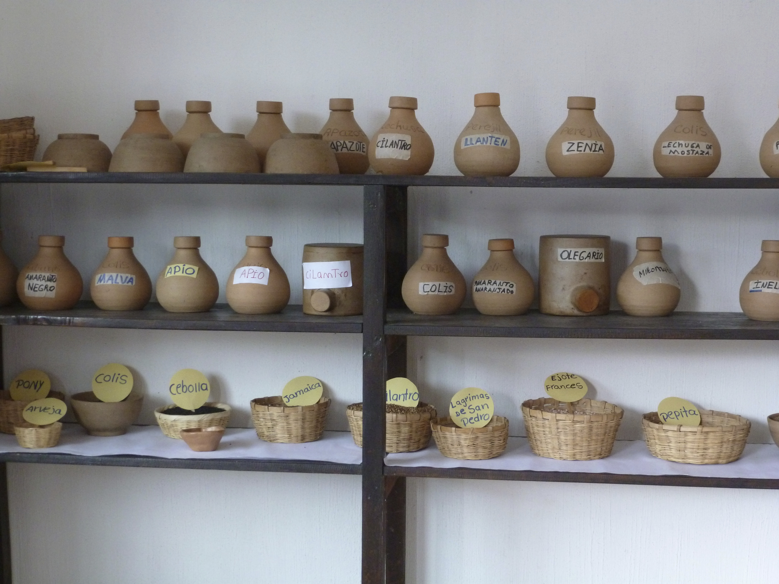  
 Seed bank at Asociacion Qachuu Aloom

### Private Enterprise

Several days later, Karla accompanied the team to San Marcos, where they met with an entrepreneur named Juan Carlos, who grew and sold amaranth as a side job. Juan Carlos talked for hours about the work he had done to build his business and about his dream of growing large enough that he could employ local farmers to supply him with amaranth. The team was impressed with his passion and drive and could not help but wonder whether CRS should consider cultivating enterprising individuals like Juan Carols, who could fulfill the middleman role traditionally served by a cooperative.

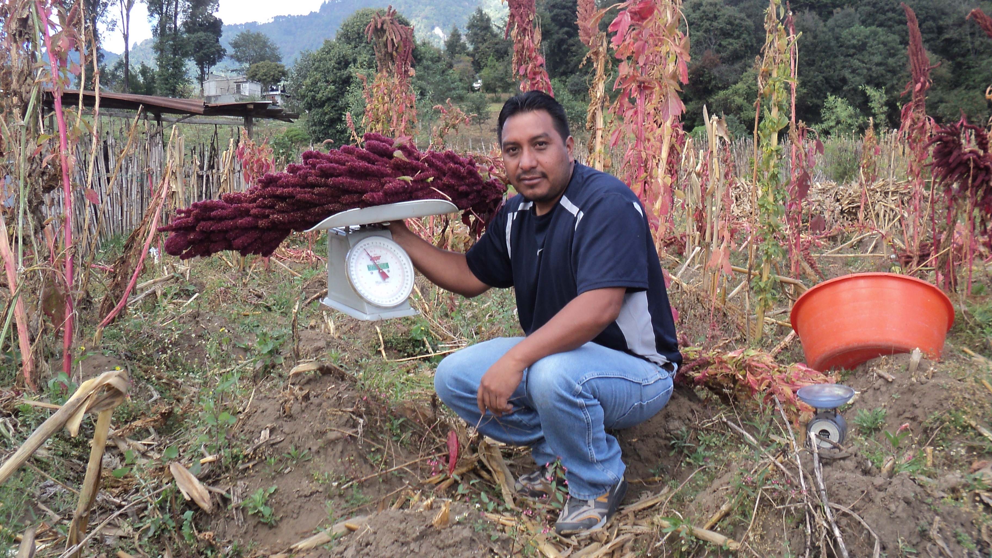  
 Juan Carlos in his amaranth field

Many in the development community, most notably organizations like the Acumen Fund, believe that investing in private entrepreneurs is a better way to support development, because the strategy leverages powerful economic incentives that may accelerate the go-to-market process. Investments in entrepreneurs may be made by providing scholarships, business training, or direct debt and equity investment. If the right entrepreneurs are selected, private businesses can function in essentially the same market capacity as a cooperative, and serve a social goal. Ideal entrepreneurs have both business ability as well as a concern for the mission of poverty alleviation in rural areas.

Karla was wary of the private enterprise approach, having seen intermediaries take advantage of farmers in the past. Furthermore, as a peace builder, Karla was concerned that entrepreneurial investments did little to strengthen communities. But she could not deny that an entrepreneurial model offered attractive benefits for efficiency, compared to a slow, plodding cooperative, like Todos Hermanos. A private business was also far more likely to retain qualified management.

**So Many Questions**

Karla knew that Emilio was not a bad person, but she had begun to realize that a good heart does not necessarily make a good leader. Monseñor was the glue that kept the Todos Hermanos cooperative intact. When the community lost him, Emilio simply did not have the same credibility and could not command the same level of engagement from co-op members.

Karla knew it would take a long time to recover from the disappointment of Todos Hermanos’ tragic failure but she refused to let the situation make her jaded. She was determined to take away the right lessons from this experience that would make her a more effective development professional, in the future. As she mentally replayed the story of Todos Hermanos, she wondered….

*What is the complete set of possible explanations for the failure of Todos Hermanos? Was it leadership? Cooperative governance issues? Narco-coffee traders? Market pressures? Was there something else she wasn’t seeing?*

*Could a different organizational structure, like the examples she observed with the BOTFL VI team, have provided a better opportunity for the farmers in Zacapa? Or would any organizational structure fail, given the same crisis of leadership experienced when the Monseñor left?*

*If it is a matter of leadership, how can NGO’s like CRS find and develop leaders who are capable of performing such challenging work and who can gain the trust of the farmers even while making unpopular decisions needed for the success? Who would be motivated to take on a task for such meager pay when other opportunities exist? What can be done to make these positions more attractive?*

-Written By David Paul & Jessica Bonanno